Year 2025.

Welcome to Phoenix Station, formerly Toronto, population 65,000.

8 years ago, a virus of unknown origin started an epidemic in Cape Town, MN.

The virus was fatal to human beings, killing them in minutes after onset.

But what’s worse, the corpses were somehow reanimated by the virus.

A reanimated corpse, dubbed a “zombie” or a “walker”, mindlessly attacks live human beings, spreading the virus through open wounds.

Within months, the world’s population dropped to 35 million people, or 0.5%.

It seems to be human’s extinction event.

But, in about 0.03% of humans who contracted the virus, they did not turn into zombies. Instead, the virus mutated and co-existed with their systems, and they gained super-human strength.

Immunity and superior physique made these people the perfect weapon to fight against zombies. Conscription is the policy in this current state of emergency.

To the common people, they are known as the -

|  |
| --- |
| e.t. games    presentS |
| Sentinels |
| A post-zombie-apocalyptic FPS |
| Version Beta 1.0  All work Copyright © 2016 by E.T. Games.  All rights reserved. |
| **Thiago de Andrade Souza, Eddie Song** |
|  |

|  |
| --- |
| December 4th 2016 |

Contents

Game Overview 7

Controls 7

Game Play / Highlights 7

Classes 8

Assassin 8

Crusader 8

Shadow 9

Elementalist (future) 9

Blade Master (future) 9

Levels 9

Abandoned Hospital 10

Infected Forest 10

Endless Massacre 10

Enemies 10

Weapons 10

Scoring 11

Screenshots 12

Art/Multimedia/Sound Index 16

Future Plans 17

Design Notes 17

**Version History**

|  |  |  |  |
| --- | --- | --- | --- |
|  |  |  |  |
| 739a796 | Eddie Song | Mon Dec 19 21:11:13 2016 | 2016-12-19 build for project submission |
| cd72e01 | Eddie Song | Mon Dec 19 18:48:25 2016 | Preparation for submission |
| 40868f8 | Eddie Song | Sat Dec 17 17:06:39 2016 | Integration of levels |
| bebf0a3 | Eddie Song | Sat Dec 17 16:46:25 2016 | merge result |
| ee96aa4 | Thiago Andrade | Sat Dec 17 13:36:07 2016 | scene fix |
| c35d27e | Thiago Andrade | Sat Dec 17 01:29:46 2016 | removing wav file |
| 5f64b38 | Thiago Andrade | Sat Dec 17 01:27:18 2016 | thiago recording |
| add30b1 | Eddie Song | Fri Dec 16 23:14:58 2016 | Added main menu, zombie spawn points, and a whole bunch of game logic, and an endless level, and other things but I'm too tired to go through them one by one |
| 5145c1d | Thiago Andrade | Fri Dec 16 22:02:49 2016 | pickup item and scripts |
| 82fd4a3 | Thiago Andrade | Fri Dec 16 20:20:04 2016 | weapon controller fixed |
| 472976f | Thiago Andrade | Fri Dec 16 20:14:41 2016 | null pointer ex fix |
| 1ec28db | Eddie Song | Fri Dec 16 18:23:25 2016 | Added zombie spawn script, fixed numerous things, imported and modified hospital level. |
| fc81533 | Thiago Andrade | Fri Dec 16 00:34:34 2016 | level complete; level boss; status message on UI |
| e2a5a0b | Thiago Andrade | Wed Dec 14 22:57:19 2016 | doors opening with c key; more level items; zombie boss of the level |
| c1f6831 | Thiago Andrade | Wed Dec 14 18:47:36 2016 | creating door |
| cab6df8 | Thiago Andrade | Wed Dec 14 15:59:35 2016 | zombies not getting hurt bug fix; zombies sounds |
| 4c12573 | Eddie Song | Tue Dec 13 23:11:39 2016 | Finished UI, added kill streak text. Adrenaline Rush functional and tested. |
| 4baf76b | Eddie Song | Tue Dec 13 20:26:34 2016 | Tweaked scripts, refactored code for clarity |
| b277bf0 | Eddie Song | Tue Dec 13 18:56:17 2016 | Made initial UI, fixed weapon animation to work with scaled time |
| d3ac1be | Thiago Andrade | Mon Dec 12 23:54:47 2016 | new skybox |
| 83bbe1b | Thiago Andrade | Mon Dec 12 23:39:59 2016 | merge result |
| c88ee7e | Thiago Andrade | Mon Dec 12 23:36:00 2016 | level 2 initial design |
| dd1de80 | Eddie Song | Mon Dec 12 21:47:54 2016 | Missed one file |
| 7c564a6 | Eddie Song | Mon Dec 12 21:46:55 2016 | Zombie attack trigger functional (calling correct method on WeaponControl), next step: add zombie sounds, add UI |
| 0bcaf20 | Eddie Song | Mon Dec 12 20:42:25 2016 | Added basic zombie attack function and trigger |
| c76375c | Thiago Andrade | Mon Dec 12 01:36:25 2016 | fixing minor bugs |
| 88de30b | Eddie Song | Sun Dec 11 23:54:00 2016 | A BIG COMMIT: Added weapon spread (recoil). Added abilities to slow time and turn undetectable. Added camera filters to indicate abilities being used. |
| 946e1aa | Eddie Song | Sun Dec 11 18:58:23 2016 | Zombies will now take damage from gun fire, bleed, and die. |
| 0bc5c14 | Thiago Andrade | Sun Dec 11 12:43:09 2016 | raining |
| 8ffc63f | Thiago Andrade | Sun Dec 11 12:33:39 2016 | rain particle system |
| c00f69f | Eddie Song | Sat Dec 10 16:26:38 2016 | Made UI a part of player prefab, minor fixes |
| 412dbb4 | Eddie Song | Sat Dec 10 16:15:30 2016 | Adjusted zombie prefab and attached colliders to all limbs |
| e0c4ab5 | Eddie Song | Sat Dec 10 14:39:30 2016 | Added logic and animation for weapon reload and ammo system |
| 3e7555d | Eddie Song | Fri Dec 9 14:16:58 2016 | Added weapon swap function and animation (shooting disabled during animation). Added basic firing function (raycast), which spawns effects at impact. |
| e69ef34 | Thiago Andrade | Tue Dec 6 02:02:28 2016 | Merge branch 'master' of https://github.com/eddieysong/COMP305_Final_Project |
| 8aa6a48 | Thiago Andrade | Tue Dec 6 02:02:21 2016 | game external documentation |
| 8f72e29 | Thiago Andrade | Tue Dec 6 02:01:05 2016 | Update README.md |
| 9f39958 | Thiago Andrade | Tue Dec 6 02:00:01 2016 | Merge branch 'master' of https://github.com/eddieysong/COMP305_Final_Project |
| 6094d5b | Thiago Andrade | Tue Dec 6 01:59:11 2016 | screen shots |
| effb131 | Thiago Andrade | Tue Dec 6 01:56:28 2016 | Create README.md |
| 96f0c9b | Thiago Andrade | Tue Dec 6 01:53:44 2016 | new scene, new zombie, zombie walking, a few useful textures |
| ca04f81 | Eddie Song | Sat Dec 3 15:18:39 2016 | A late initial commit with weapon models, weapon camera set up, weapon swapping, weapon sounds. |

# Game Overview

As a protector of humans, a sentinel member is involved with tasks such as performing organized assaults, escorting citizens, and salvaging important material in densely populated zombie areas.

Depending on the mutation of the virus, sentinels have different types of abilities. For example, some gain super-human speed and reaction. Some can regenerate body tissues rapidly. There are others who can suppress their vital signs to a minimum and walk through zombies nonchalantly.

Sentinel members are given as much freedom as possible when it comes to how to use their unique ability in the fight against zombies.

In this game, the player takes on the role of a sentinel member, and is taken through a series of campaign missions.

# Controls

The game is developed to function like a classic first-person shooter. Players control a character with first-person perspective, and use the mouse/game controller to fire at zombies and kill them.

player movement is controlled by the WASD keys for directional movement and space for jumping. Clicking or holding the left mouse button will fire single or consecutive rounds of the player’s weapon. F key activates the player character’s class ability.

# Game Play / Highlights

Zombie shooters usually have a short life span (except the really well-made ones like L4D and Resident Evil, etc.), partially because there just isn’t enough variety in the game.

We seek to rectify this problem by letting the player choose a class. A feature we planned for the future will allow a player to gain experience points for a class as he completes more missions with the class, which in turn allows the player to access more sophisticated skills and perks.

Our design principle is to give every single class a unique identity, and vastly different but effective play styles.

# Classes

Classes are based on the types of virus mutation in the player character, and function like classic RPG classes. Each class has its unique playstyle, such as hit-and-run or stealth.

## Assassin

Assassins are sentinels whose mutation gave them superior reflexes and speed. Utilizing concentrated, short-range firepower in a hit-and-run pattern, assassins work well for those who like to play a fast, versatile class.

The assassin has access to Adrenaline Rush, an active ability that slows down time to simulate the effect of having super-human speed and reaction. When Adrenaline Rush is activated, camera motion blur comes into effect to indicate the skill's activation, and the world is slowed down to a quarter of real time. During this time, the player's reload animation remains the same, but everything else gets slowed down accordingly.

## Crusader

Crusaders have superior strength and can move around with heavy weaponry such as machine guns and rocket launchers. Their mutation also enables them to regenerate muscle tissues rapidly by speeding up metabolism. Crusaders are for players who favor heavy firepower at the cost of mobility.

The crusader's active skill is Fortress, during which the crusader's biological system maximizes his physical strength at the cost of mobility. When Fortress is activated, the crusader's movement speed is slowed to a crawl, but he gains extra damage reduction and his accuracy will only suffer a fraction of the normal amount from recoil.

## Shadow

By suppressing vital signs like breath and heartbeat, A shadow sentinel tends to set up the scene for herself before revealing herself in a fit of destruction. As “phasing out” puts a strict limit on their physical capability, shadows usually rely on light weaponry such as silenced pistols and C-4 explosives, and make up for that lack of firepower by placing it in the perfect location.

Shadows can minimize their vital signs and become undetectable by zombies. By using her Phase Walk ability, zombies will no longer target her, and she has the opportunity to re-position herself before coming out of stealth.

## Elementalist (future)

An elementalist is a sentinel with the power to transfer heat energy rapidly around them. Their power wasn’t really sufficient to fight zombies until the TEGA, the thermal energy generator/amplifier was developed. TEGA functions as a conduit and allows an elementalist to use their powers to kill.

## Blade Master (future)

Blade Masters are very similar to assassins in terms of mutation, but they use their ability in an entire different way. Favoring cold steel to hot barrels, blade masters use their agility and speed to navigate through zombies while chopping off their heads. Unhindered by the need to carry ammo, blade masters can carry more explosives, healing items and utility items.

# Levels

There are three levels at the moment:

## Abandoned Hospital

The player is sent on an assault mission to clear an abandoned hospital of zombies. The mission is completed when the player kills a total of 50 zombies.

## Infected Forest

The player is sent to an area to investigate a possible mutant zombie, and must destroy the boss mutant zombie to complete the mission.

## Endless Massacre

An endless level, zombies will get stronger for every 12 zombies spawned.

# Enemies

There are 3 types of enemies at the moment:

* Strong zombie: moves slowly, but hits hard and has more health
* Fast zombie: moves quickly, but has less health and doesn’t hit as hard
* Boss zombie: Massive in size, has a ton of health, and hits really hard

# Weapons

There are 3 types of weapons at the moment:

* AK-47: it’s an implicit rule that every FPS game must have this rifle.
  + Clip size: 30.
  + Rate of fire: 8.33 rounds/sec.
  + Base damage: 15 points/shot.
* M4A1: As a nod to the legendary multiplayer FPS Counter-Strike, we included the M4 as a counterpart to the AK.
  + Clip size: 30.
  + Rate of fire: 10 rounds/sec.
  + Base damage: 12 points/shot.
* UMP-45: The only submachinegun available at the moment, it offers more maneuverability than rifles.
  + Clip size: 35.
  + Rate of fire: 12.5 rounds/sec.
  + Base damage: 7.5 points/shot.

# Scoring

The player gains 1 points for each headshot, and 5 points for killing a zombie. The points system is a precursor to the experience points/leveling system we have described before.

# Screenshots

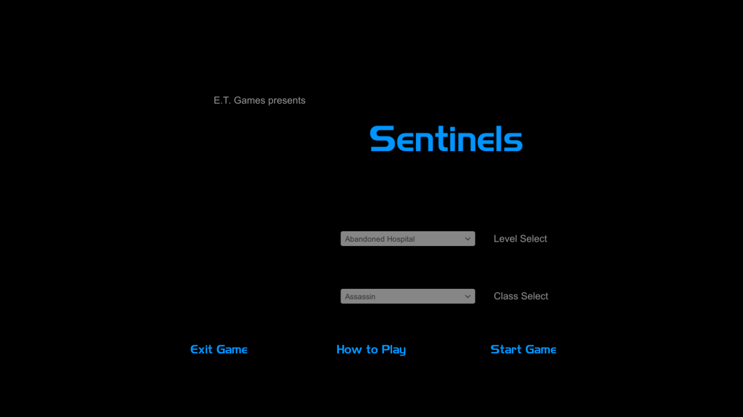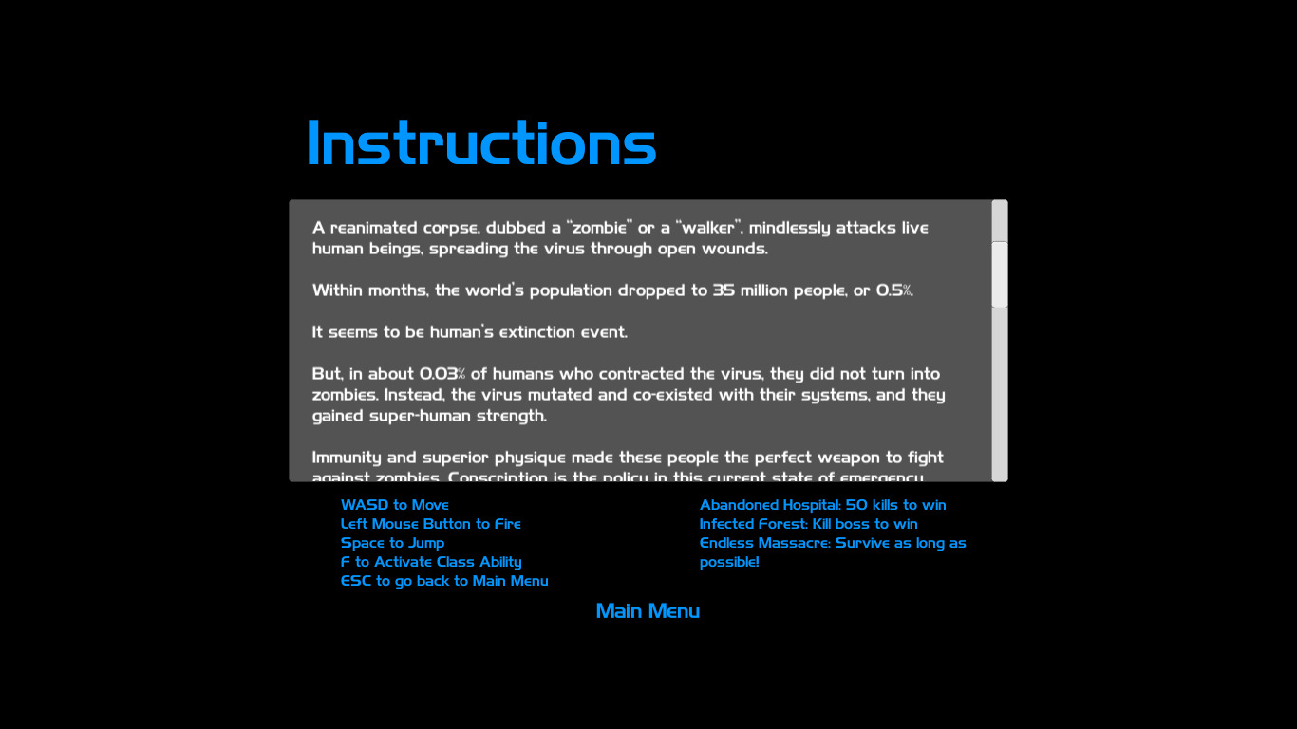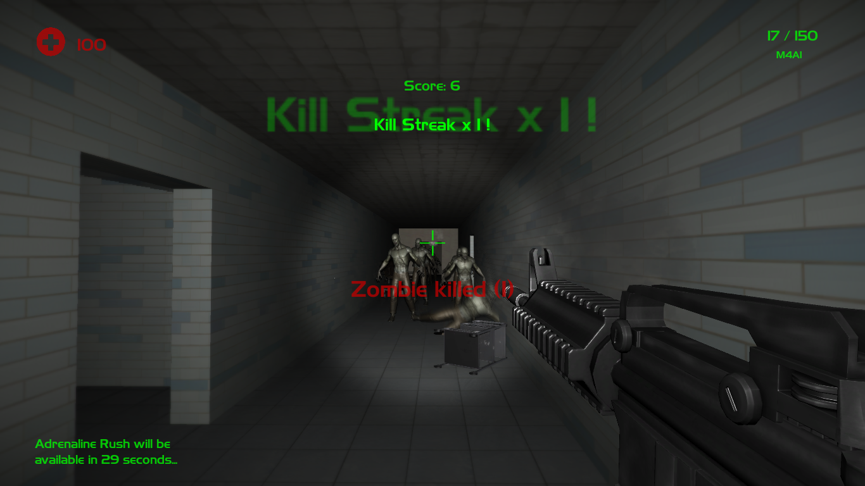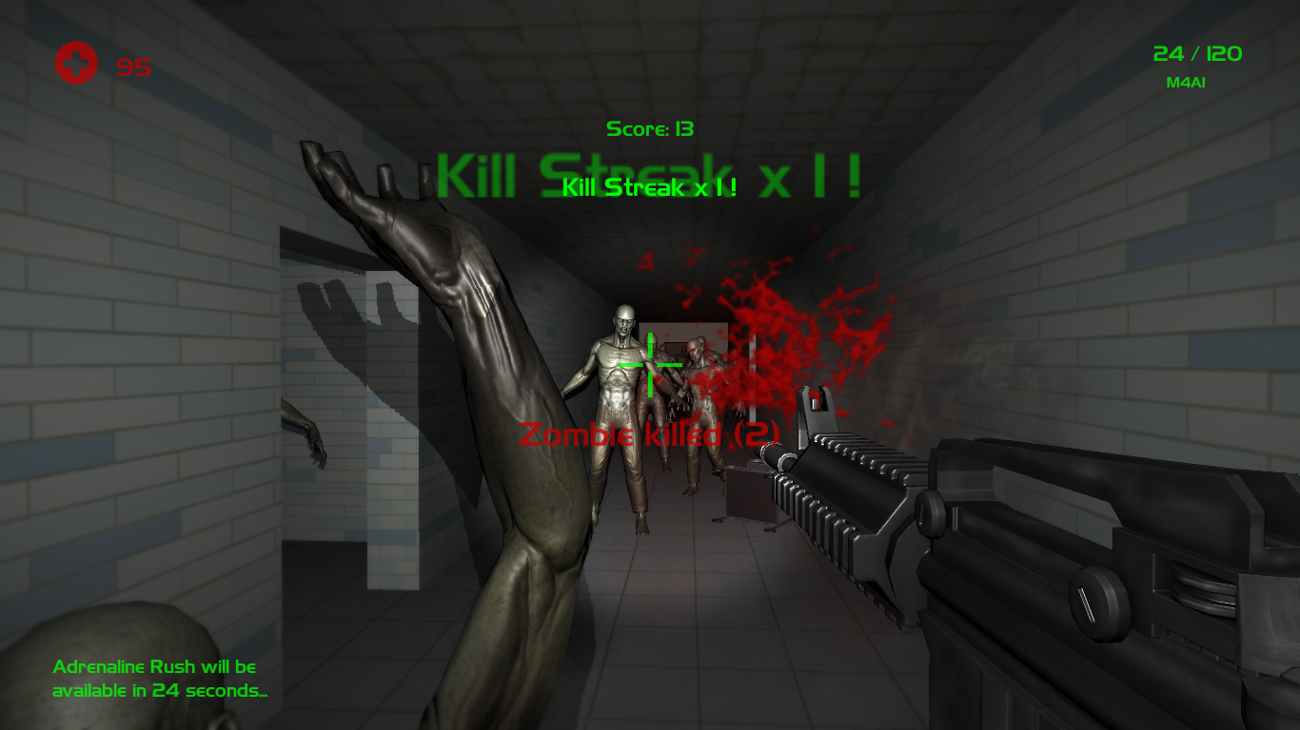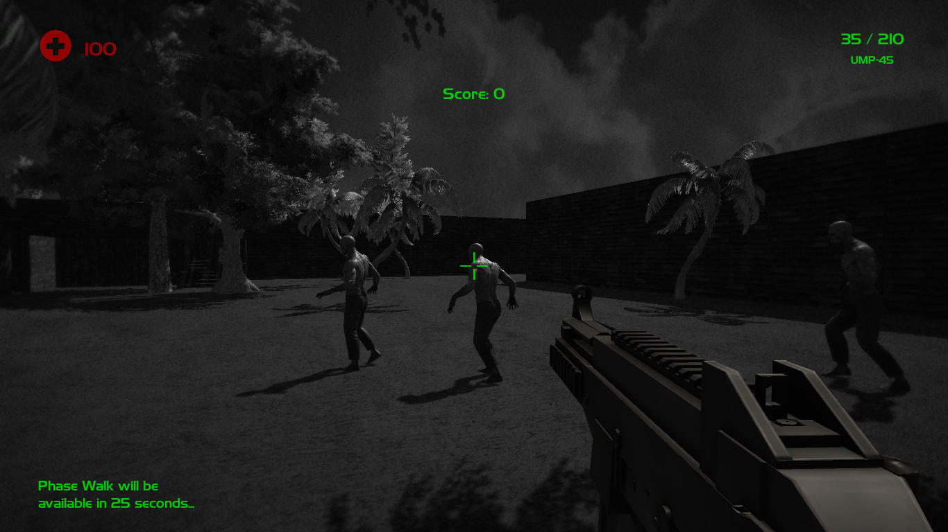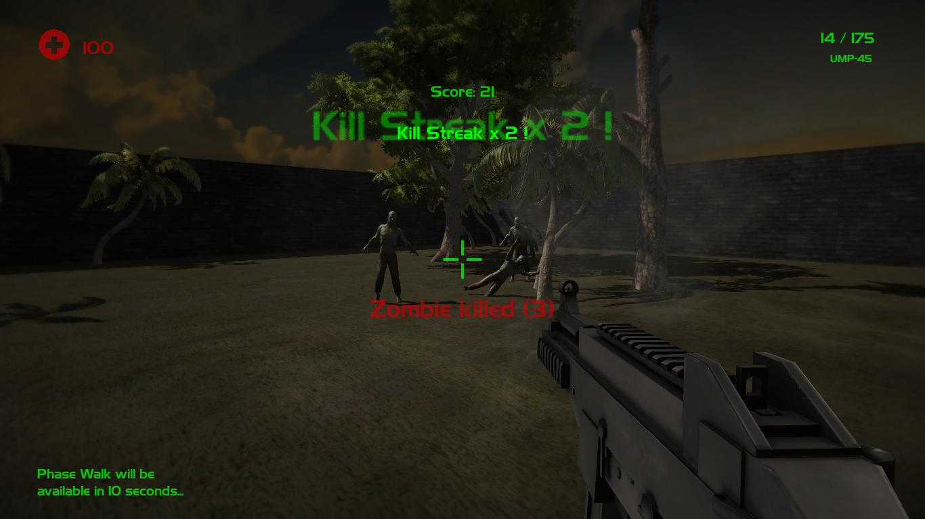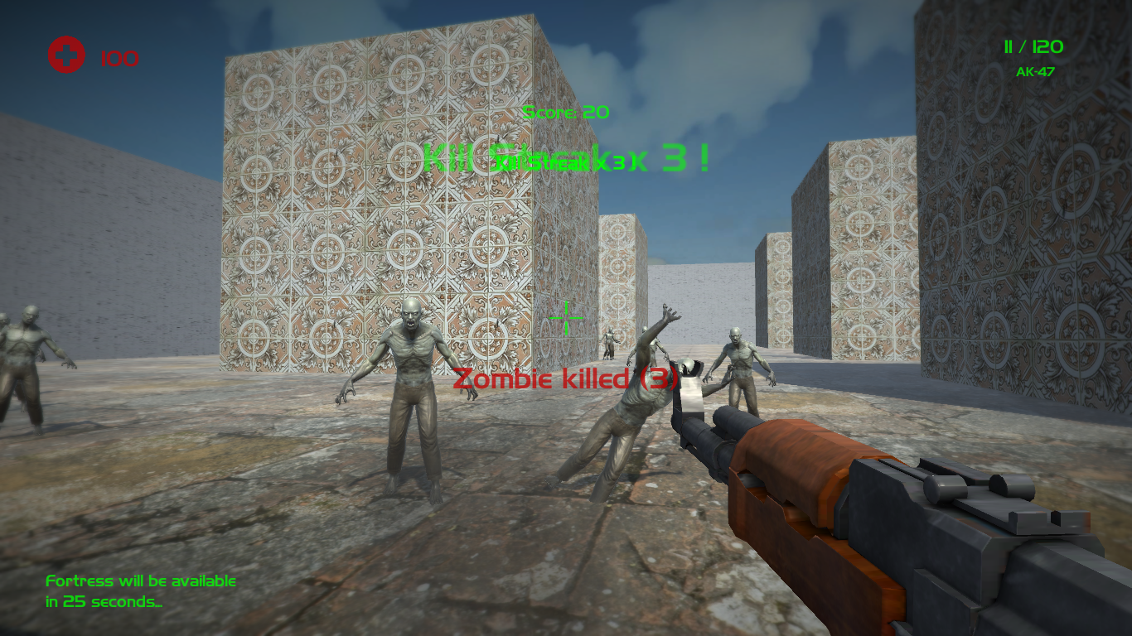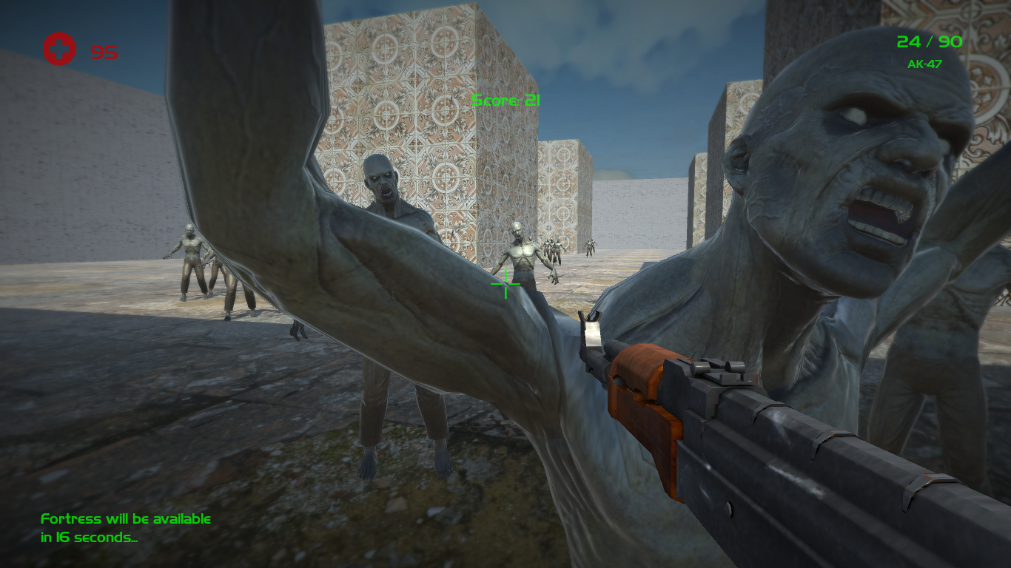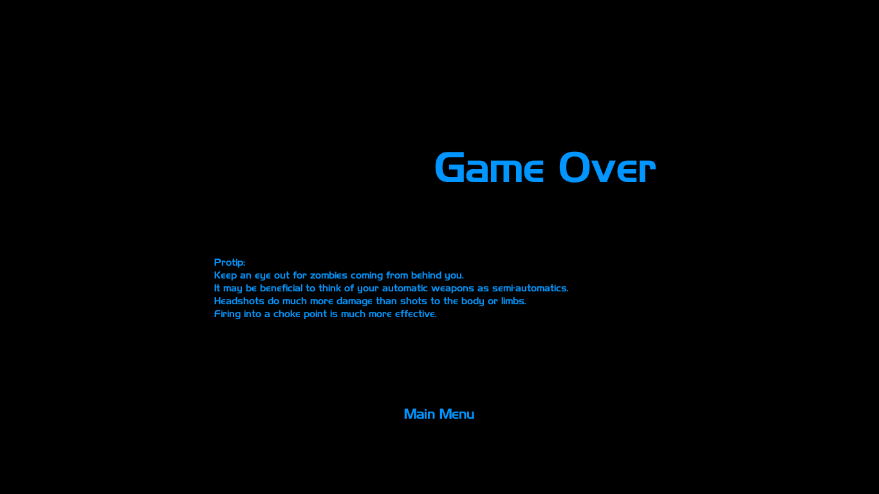

# Art/Multimedia/Sound Index

We are using some packages from the Unity asset store as well as the Internet. Here’s a list of the packages:

* Unity Standard Assets (<https://www.assetstore.unity3d.com/en/#!/content/32351>)
* Realistic LowPoly Guns (<https://www.assetstore.unity3d.com/en/#!/content/9934>)
* Modern Weapons Pack (<https://www.assetstore.unity3d.com/en/#!/content/14233>)
* M67 Frag Grenade (<https://www.assetstore.unity3d.com/en/#!/content/9527>)
* Zombie (<https://www.assetstore.unity3d.com/en/#!/content/30232>)
* Realistic FPS Pack (Muzzleflash/Impacts) (<https://www.assetstore.unity3d.com/en/#!/content/21187>)
* Gun Sounds Pack 2.0 (<http://sweetsoundeffects.com/gun-pack-2/>)
* Classic skybox (<https://www.assetstore.unity3d.com/en/#!/content/24923>)
* Common Loot Kit Sample (<https://www.assetstore.unity3d.com/en/#!content/22280>)
* Free Furniture Set (<https://www.assetstore.unity3d.com/en/#!/content/26678>)
* Horror Hospital Pack (<https://www.assetstore.unity3d.com/en/#!/content/44045>)
* Metal Mayhem Music Pack (<https://www.assetstore.unity3d.com/en/#!/content/19233>)

Due to the number of assets used, it wouldn’t be a good use of space to list every asset as a thumbnail in this document.

# Future Plans

Sentinels was conceived as a bigger project. Our vision included:

* a more sophisticated weapon system (similar to that of borderlands)
* a deep character development system (leveling up brings different improvements)
* a core loop for game progression (a campaign, or making progress in rebuilding a shelter for humans, etc.)
* online co-op/Multiplayer mode

As Rome wasn’t built in a day, this project will remain an ongoing effort. As one of the developers have received a job offer (Congrats Thiago!), it may be a long way to go before the game is as complete and polished as we want it to be.

# Design Notes

This game was conceived without wireframing, because the person who designed the HUD (Eddie) is a veteran in FPS games, and has a distinct sense of where he would like everything to be.

Special thanks go to our instructor, Tom Tsiliopoulos, who was instrumental in our successful learning process.

We also want to thank the pioneers of the FPS genre, such as the developers of Doom, Quake, Counter-Strike, Battlefield, Call of Duty, Borderlands, without whom there wouldn’t be inspiration for this game.